PROJECT-49
AI Image Prompt Generator
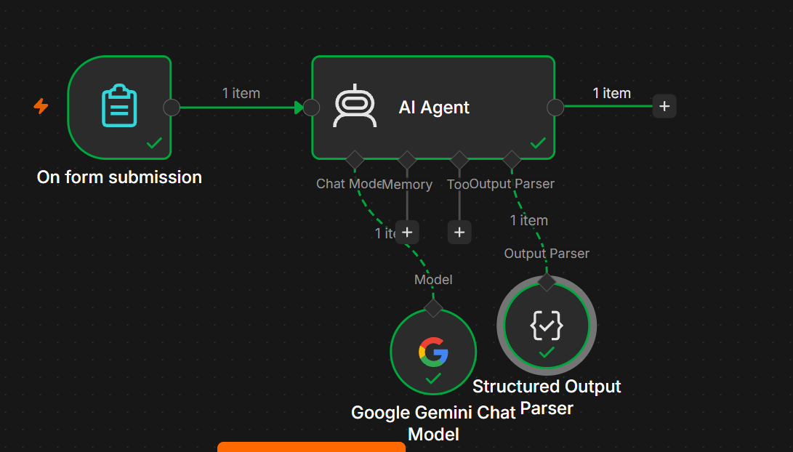
For your medium-level AI Agent practice, build this using the same simple structure.
You do NOT need a Vector Store. ✅
On Form Submission
↓
AI Agent
↙ ↘
Gemini Output Parser
The purpose is to take a simple idea and turn it into a detailed, ready-to-use image-generation prompt.

1. Project Objective
The AI Image Prompt Generator converts basic user input into a professional prompt that can be used with image-generation tools such as image models.
Example Input
Subject:
Coffee shop

Style:
Cinematic

Purpose:
Instagram advertisement

Colors:
Warm brown and gold

Additional Details:
Modern coffee shop with people working on laptops
AI Output
{
"prompt": "A cinematic modern coffee shop filled with natural warm lighting, customers working on laptops, elegant wooden interiors, rich brown and gold tones, realistic photography, inviting atmosphere, premium commercial advertising style...",
"negative_prompt": "blurry, low quality, distorted faces, extra fingers, text, watermark",
"style": "Cinematic commercial photography",
"aspect_ratio": "1:1"
}

2. Nodes Required
Use only:
- On Form Submission
- AI Agent
- Google Gemini Chat Model
- Structured Output Parser
You DON'T need:
❌ Vector Store
❌ Data Loader
❌ Text Splitter
❌ Embeddings
Because the AI is generating a prompt from the user's input, not searching a knowledge base.

3. Step 1 — On Form Submission
Add:
On Form Submission
Create these fields.

Field 1 — Subject
Type: Text
Subject
Example:
Luxury Coffee Shop

Field 2 — Image Style
Type: Text
Image Style
Example:
Cinematic photography
You can also use:
Realistic
Anime
3D Render
Watercolor
Minimalist
Product Photography
Illustration

Field 3 — Purpose
Type: Text
Purpose
Example:
Instagram advertisement

Field 4 — Mood
Type: Text
Mood
Example:
Warm and premium

Field 5 — Colors
Type: Text
Colors
Example:
Brown, gold and cream

Field 6 — Additional Details
Type: Text Area
Additional Details
Example:
Modern coffee shop with people working on laptops,
large windows, wooden furniture and indoor plants.
Use Text Area here because the user may provide detailed requirements.

4. Example Form
Your form should look like:
Subject:
Luxury Coffee Shop

Image Style:
Cinematic photography

Purpose:
Instagram advertisement

Mood:
Warm and premium

Colors:
Brown, gold and cream

Additional Details:
Modern coffee shop with people working on laptops,
large windows, wooden furniture and indoor plants.

5. Step 2 — AI Agent
Connect:
On Form Submission
↓
AI Agent

6. AI Agent Prompt
Select:
Prompt (User Message) → Define below
Use:
Create a detailed image-generation prompt using the following information.

Subject:
{{ $json['Subject'] }}

Image Style:
{{ $json['Image Style'] }}

Purpose:
{{ $json['Purpose'] }}

Mood:
{{ $json['Mood'] }}

Colors:
{{ $json['Colors'] }}

Additional Details:
{{ $json['Additional Details'] }}

Generate a professional image prompt.

The prompt should describe:
1. Main subject
2. Environment/background
3. Composition
4. Lighting
5. Camera or visual perspective when appropriate
6. Colors
7. Mood
8. Artistic or photographic style
9. Important details
10. Output format recommendation

Also generate a negative prompt to identify things that should be avoided.

7. System Message
Use:
You are an AI Image Prompt Generator.

Your job is to transform simple user ideas into detailed,
clear and useful prompts for image-generation models.

IMPORTANT RULES:

1. Preserve the user's main subject and requirements.
2. Do not change the intended concept.
3. Add useful visual details where appropriate.
4. Describe composition and environment clearly.
5. Include lighting and mood.
6. Include suitable visual style.
7. Include colors when provided.
8. Suggest an appropriate camera perspective when relevant.
9. Avoid unnecessary complexity.
10. Do not add text, logos or watermarks unless explicitly requested.
11. Generate a useful negative prompt.
12. Recommend an appropriate aspect ratio based on the purpose.
13. Do not claim that the prompt guarantees a specific image result.
14. Return the result using the required structured output format.

8. Step 3 — Google Gemini Chat Model
Add:
Google Gemini Chat Model
Connect it to the AI Agent's:
Chat Model input.
Correct:
Google Gemini Chat Model
↓
AI Agent

9. Step 4 — Structured Output Parser
Add:
Structured Output Parser
Connect it to:
AI Agent → Output Parser
AI Agent
↓
Output Parser
↓
Structured Output Parser

10. JSON Output Format
Select:
Generate from JSON Example
Use:
{
"image_prompt": "A cinematic modern luxury coffee shop with large windows, elegant wooden furniture, indoor plants and customers working comfortably on laptops. Warm natural sunlight enters through the windows, creating a premium and inviting atmosphere. Rich brown, gold and cream color palette, realistic commercial photography, balanced composition, eye-level perspective, detailed textures, soft shadows, high-end advertising aesthetic.",
"negative_prompt": "blurry, low resolution, distorted objects, distorted faces, extra fingers, bad anatomy, watermark, unwanted text, oversaturated colors",
"style": "Cinematic commercial photography",
"mood": "Warm and premium",
"aspect_ratio": "1:1",
"recommended_use": "Instagram advertisement"
}

11. Final Workflow
Your n8n canvas should look like:
┌─────────────────────────┐
│ On Form Submission │
│ │
│ Subject │
│ Image Style │
│ Purpose │
│ Mood │
│ Colors │
│ Additional Details │
└────────────┬────────────┘
│
▼
┌─────────────┐
│ AI Agent │
└──────┬──────┘
│
▼
Structured Output Parser
And:
Google Gemini Chat Model
↓
AI Agent

12. Test It
Use this first.
Subject
Luxury Coffee Shop
Image Style
Cinematic photography
Purpose
Instagram advertisement
Mood
Warm and premium
Colors
Brown, gold and cream
Additional Details
Modern coffee shop with people working on laptops,
large windows, wooden furniture and indoor plants.

13. Expected Output
You should get something similar to:
{
"image_prompt": "A cinematic luxury coffee shop with modern wooden interiors, large windows, indoor plants and customers working on laptops. Warm natural lighting, rich brown and gold tones, premium atmosphere, realistic commercial photography, detailed textures, balanced composition and soft shadows.",
"negative_prompt": "blurry, low quality, distorted objects, distorted faces, extra fingers, watermark, unwanted text",
"style": "Cinematic photography",
"mood": "Warm and premium",
"aspect_ratio": "1:1",
"recommended_use": "Instagram advertisement"
}
The exact wording will vary. That is normal.

14. Aspect Ratio Logic
The AI can recommend an aspect ratio based on the purpose.
Purpose | Suggested Ratio
Instagram Post | 1:1
Instagram Story | 9:16
YouTube Thumbnail | 16:9
Website Banner | 16:9
Product Image | 1:1
Blog Image | 16:9
Portrait | 4:5
Landscape Advertisement | 16:9
You can add this instruction to your system message:
Choose the aspect ratio based on the intended use:
Instagram Post = 1:1
Instagram Story = 9:16
YouTube Thumbnail = 16:9
Website Banner = 16:9
Product Image = 1:1
Blog Image = 16:9
Portrait = 4:5

15. Test 2 — Product Image
Subject
Wireless Headphones
Style
Professional product photography
Purpose
E-commerce product page
Mood
Premium and modern
Colors
Black and silver
Additional Details
Headphones placed on a clean reflective surface,
soft studio lighting, minimal background.
Expected:
Style → Professional product photography
Aspect Ratio → 1:1

16. Test 3 — Social Media
Subject
Fitness Motivation
Style
Realistic photography
Purpose
Instagram Story
Mood
Energetic and motivational
Colors
Black, red and white
Details
Athlete exercising in a modern gym,
dramatic lighting and dynamic composition.
Expected:
Aspect Ratio → 9:16

17. Test 4 — YouTube Thumbnail
Subject
AI Learning
Style
3D digital illustration
Purpose
YouTube Thumbnail
Mood
Futuristic and exciting
Expected:
Aspect Ratio → 16:9

18. What the Output Means
Image Prompt
The actual detailed prompt you can copy into an image-generation model.
Negative Prompt
Things you want the image model to avoid.
Example:
blurry, distorted, low quality, watermark
Style
The visual style.
Example:
Cinematic photography
Mood
The emotional/visual feeling.
Example:
Warm and premium
Aspect Ratio
The recommended image dimensions/shape.
Example:
1:1
Recommended Use
Where the generated image is intended to be used.

19. Medium-Level Features
Your project is medium-level because it doesn't just generate one prompt.
It performs multiple tasks:
User Input
↓
AI Analysis
↓
Detailed Prompt
↓
Negative Prompt
↓
Style
↓
Mood
↓
Aspect Ratio
↓
Recommended Use
It also uses:
- Form input
- Dynamic n8n expressions
- AI Agent
- Gemini
- Prompt engineering
- Structured Output Parser
- Conditional aspect-ratio reasoning

20. Optional Advanced Version
Once the basic workflow works, you can connect the generated prompt directly to an image-generation model:
On Form Submission
↓
AI Image Prompt Generator
↓
Image Generation Model
↓
Generated Image
For example:
Form
↓
AI Agent
↓
Image Prompt
↓
Image Generation
↓
Image Output
That would turn this from a Prompt Generator into a complete AI Image Generation Agent.

21. Final Project Summary
Input
Subject
Image Style
Purpose
Mood
Colors
Additional Details
Processing
Google Gemini
+
AI Agent
+
Prompt Engineering
Output
Image Prompt
Negative Prompt
Style
Mood
Aspect Ratio
Recommended Use
Final Architecture
On Form Submission
↓
AI Agent
↙ ↘
Gemini Output Parser
↓
Structured JSON
For this version, do not add Vector Store, embeddings, Data Loader, or Text Splitter. They are unnecessary because the AI is generating a prompt directly from the user's form input.

